IdeationPhase

DefinetheProblemStatements

|  |  |
| --- | --- |
| Date | 27June2025 |
| TeamID | LTVIP2025TMID3376 |
| ProjectName | Pattern sense:ClassifyingFabricPatternsusingDeep Learning |
| MaximumMarks | 2Marks |

**CustomerProblemStatementTemplate:**

Create a problem statement to understand your customer's point of view. The Customer Problem Statement template helps you focus on whatmatterstocreateexperiencespeople will love.

A well-articulated customer problem statement allows you and your team to find the ideal solution for the challenges your customers face. Throughout theprocess,you’llalsobeable to empathize with your customers, which helps you better understand how they perceive your product or service.

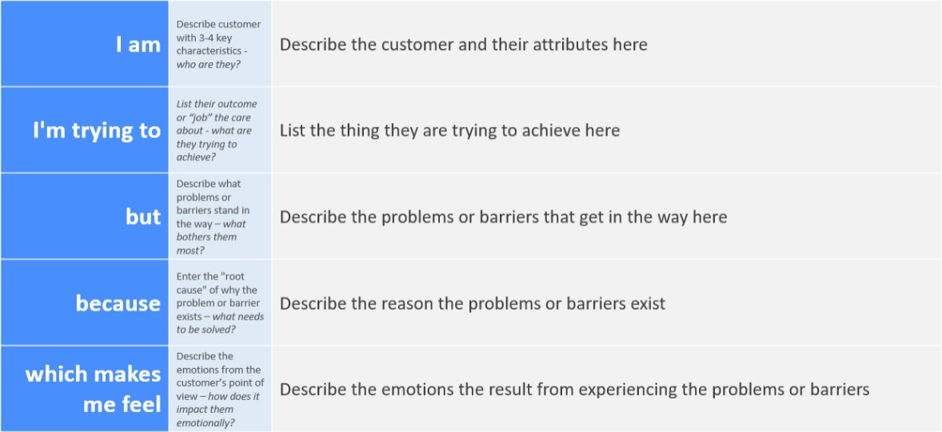

Reference:<https://miro.com/templates/customer-problem-statement/>

**Example:**

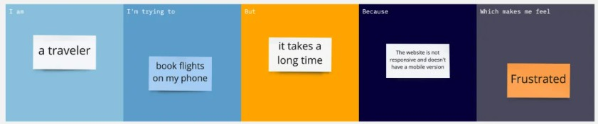

|  |  |  |  |  |  |
| --- | --- | --- | --- | --- | --- |
| **Problem**  **Statement(PS)** | **I am (Customer)** | **I’mtryingto** | **But** | **Because** | **Whichmakesmefeel** |
| PS-1 | afashion designer | identify suitable fabric  patterns quickly | manual  sorting is time-cons uming  and error-pro ne | thereisno automated system for accurate  classification | frustratedanddelayed |
| PS-2 | a textile researcher | analyzefabric types for research | existing datasets are  unorganiz ed | classification methodsare not standardized | inefficientand confused |